* Repositorio Grupal: <https://github.com/tallerintegrador2019>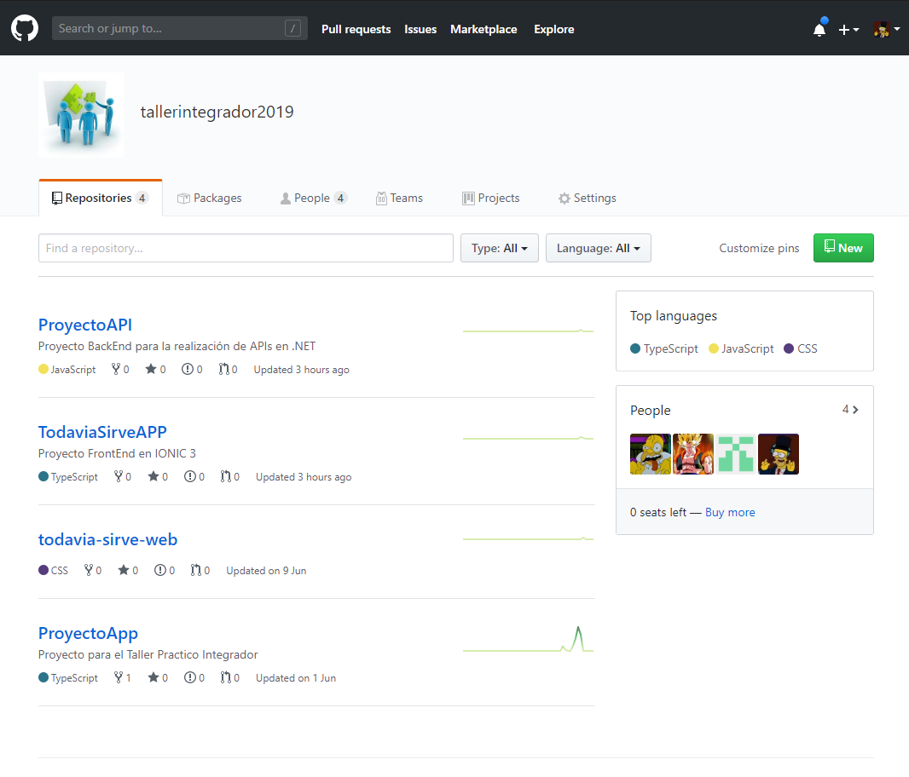
* .NET (Backend): <https://github.com/tallerintegrador2019/ProyectoAPI>
* IONIC 3 (Frontend): <https://github.com/tallerintegrador2019/TodaviaSirveAPP>